SIMATS ENGINEERING
Assessment Tool 2 — Industry Problem-Based Assignment
Expert System for Preliminary Disease Diagnosis in Healthcare
A Rule-Based System Using Forward and Backward Chaining in Prolog
Course: Artificial Intelligence and Expert Systems | Course Code: MLA01
Course Outcome: CO 5
Industry Domain Chosen: Healthcare (Option 2)

Name / Reg No: ______________________________
Signature: ______________________________

1. Title, Abstract and Introduction

1.1 Project Title
Expert System for Preliminary Disease Diagnosis Based on Patient Symptoms (Healthcare Domain).

1.2 Abstract
This project builds a small rule-based expert system that helps a hospital reception or a nurse make a quick, first-level guess about what illness a patient might have. The patient (or the staff member) simply enters the symptoms the patient is feeling, such as fever, cough, or headache. The system then looks at these symptoms, compares them with a set of stored medical rules, and suggests the most likely condition along with simple advice. The system does not replace a doctor. It only gives an early idea so the hospital can decide how urgent the case is and which department the patient should be sent to. The system is built in Prolog, a programming language that is very good at storing facts and rules and then reasoning over them.

1.3 Industry Background
Hospitals, especially large ones, receive many patients every day. Before a patient can meet a doctor, front-desk staff or triage nurses usually ask basic questions about symptoms. This step takes time and is often repeated for every patient. A simple computer program that can ask a few questions and give an early suggestion can save time, reduce the waiting queue, and help staff decide which patients need urgent attention. This kind of tool is called a decision-support tool, and it is used alongside doctors, not instead of them.

1.4 Why This Problem Is Important
- It reduces the time patients wait before seeing a doctor.
- It helps hospital staff sort patients by urgency (this is called triage).
- It shows how symptoms and diseases can be written down clearly as simple 'if-then' rules.
- It is a good real example of how Artificial Intelligence can support (not replace) human doctors.

2. Problem Statement and Objectives

2.1 Problem Statement
A hospital wants a simple tool that looks at the symptoms a patient is having (such as fever, cough, body pain, or fatigue) and gives an early idea of what illness the patient might have, along with simple, safe advice. The tool should explain its reasoning in an easy way, so staff can trust and understand the result.

2.2 Inputs
- A list of symptoms reported by the patient (for example: fever, cough, headache, chills, sore throat, fatigue, nausea, stomach pain).

2.3 Expected Outputs
- The most likely disease/condition matching the reported symptoms.
- A simple explanation of why that condition was suggested.
- Basic first-step advice (for example: rest and fluids, or see a doctor immediately).

2.4 Stakeholders
Stakeholder | Interest in the System
Patient | Gets a fast, early idea about their condition
Nurse / Front-desk staff | Uses the tool to decide urgency and which department to send the patient to
Doctor | Uses the output as a helpful first note, not a final diagnosis
Hospital management | Wants shorter queues and better use of staff time

2.5 Objectives
- Study how doctors and nurses usually connect symptoms to diseases.
- Write this medical knowledge as simple Prolog facts and rules.
- Build a knowledge base covering at least six common conditions.
- Show the system reasoning both ways: forward chaining (from symptoms to disease) and backward chaining (checking if a specific disease fits).
- Test the system with realistic patient cases and record the results.
- Explain the limitations clearly, since this is only a decision-support tool, not a real doctor.

3. Domain Analysis and Knowledge Acquisition

3.1 Where the Knowledge Came From
The medical facts used in this project are simplified and taken from general, publicly known health information (such as common descriptions of flu, cold, and malaria symptoms found in standard health-education material). The rules are kept simple on purpose, since the goal of this assignment is to demonstrate the expert system technique, not to build an official medical product.

3.2 Entities Identified
Entity Type | Examples Used in This System
Patient | The person entering symptoms
Symptom | fever, cough, body_ache, fatigue, chills, sweating, headache, sore_throat, sneezing, stomach_pain, weakness, loss_of_appetite, nausea, sensitivity_to_light, loss_of_taste, breathing_difficulty
Disease | flu, common_cold, malaria, typhoid, migraine, covid19
Advice | Short recommended first action for each disease

3.3 Facts, Conditions and Decisions
Facts: which symptoms a given patient currently has (entered by the user).
Conditions: a fixed group of symptoms that, together, point to one disease.
Decisions: the disease name the system finally suggests, plus the advice linked to it.

3.4 Symptom–Disease Map (Plain Summary)
Disease | Key Symptoms Required
Flu | fever + cough + body pain + fatigue
Common Cold | cough + sneezing + sore throat (no fever)
Malaria | fever + chills + sweating + headache
Typhoid | fever + stomach pain + weakness + loss of appetite
Migraine | headache + nausea + sensitivity to light
COVID-19 | fever + cough + loss of taste + breathing difficulty

4. Knowledge Representation and Production Rules

4.1 Facts (Prolog)
Facts store what symptoms a patient reports. In Prolog, a fact looks like this:
has_symptom(patient1, fever).
has_symptom(patient1, cough).
has_symptom(patient1, body_ache).
has_symptom(patient1, fatigue).

Each line simply says: 'this patient has this symptom.' New patients can be added by writing new facts using their own name, without changing any rule.

4.2 Production Rules (Prolog)
A production rule is written as: IF (conditions are true) THEN (conclusion is true). In Prolog this uses the ':-' symbol, which means 'is true if'.
% Rule format: has_disease(Patient, DiseaseName) :- list of needed symptoms.

has_disease(P, flu) :-
has_symptom(P, fever),
has_symptom(P, cough),
has_symptom(P, body_ache),
has_symptom(P, fatigue).

has_disease(P, common_cold) :-
has_symptom(P, cough),
has_symptom(P, sneezing),
has_symptom(P, sore_throat),
\+ has_symptom(P, fever).

has_disease(P, malaria) :-
has_symptom(P, fever),
has_symptom(P, chills),
has_symptom(P, sweating),
has_symptom(P, headache).

has_disease(P, typhoid) :-
has_symptom(P, fever),
has_symptom(P, stomach_pain),
has_symptom(P, weakness),
has_symptom(P, loss_of_appetite).

has_disease(P, migraine) :-
has_symptom(P, headache),
has_symptom(P, nausea),
has_symptom(P, sensitivity_to_light).

has_disease(P, covid19) :-
has_symptom(P, fever),
has_symptom(P, cough),
has_symptom(P, loss_of_taste),
has_symptom(P, breathing_difficulty).

4.3 Advice Rules
advice(flu, 'Take rest, drink fluids, and see a doctor if fever lasts more than 3 days').
advice(common_cold, 'Rest, warm fluids, and steam inhalation usually help').
advice(malaria, 'See a doctor immediately and get a blood test').
advice(typhoid, 'See a doctor immediately, avoid outside food, get tested').
advice(migraine, 'Rest in a dark quiet room, stay hydrated, avoid triggers').
advice(covid19, 'Isolate, monitor oxygen level, and consult a doctor immediately').

In simple words:
Facts are what we know for sure (the symptoms). Rules are the doctor-style logic ('if a patient has these symptoms, then this disease is likely'). The Prolog engine combines the two automatically to reach a conclusion.

5. Expert System Architecture

5.1 Main Parts of the System
- User Interface: where the nurse/patient types in the symptoms (in this project, the SWI-Prolog console/query is used as the interface).
- Knowledge Base: stores all the facts and production rules shown in Section 4.
- Inference Engine: the built-in Prolog engine that matches symptoms against rules to reach a conclusion.
- Explanation Module: the advice/1 rules plus the rule trace, which tells the user why a disease was suggested.

5.2 Architecture Diagram
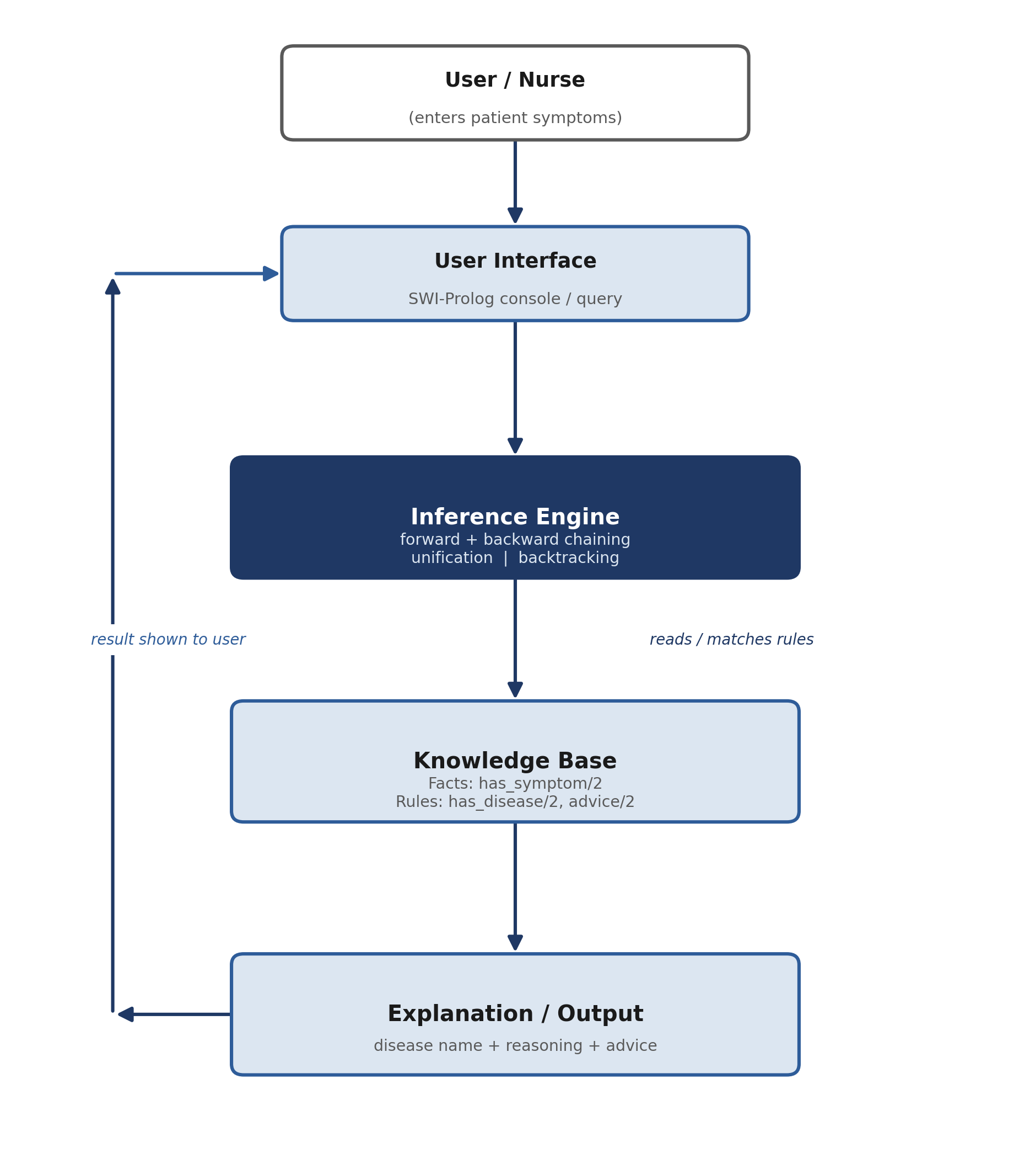
This is the classic expert system shape used in every industry example in this assignment: the user talks to an interface, the interface sends the question to the inference engine, the inference engine checks the knowledge base, and the answer comes back with an explanation.

6. Inference Mechanism and Algorithms

6.1 Forward Chaining (Data-Driven, 'Start from Symptoms')
Forward chaining starts from the known facts (the symptoms the patient has) and moves forward through the rules until a conclusion (disease) is reached. It answers the question: 'Given these symptoms, what disease matches?'
Forward Chaining Algorithm (pseudocode):
1. Collect all known facts (symptoms) for the patient.
2. For each rule (disease) in the knowledge base:
a. Check if ALL required symptoms are present in the facts.
b. If yes, add 'has_disease(Patient, Disease)' as a new fact.
3. Repeat until no new facts can be added.
4. Report all diseases that matched.

This is shown exactly as it runs in the SWI-Prolog console (screenshot-style). The file is loaded first, then the query is typed at the '?-' prompt:
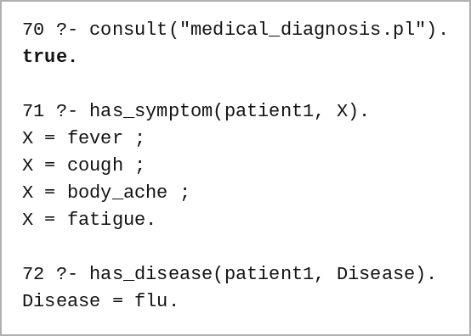

6.2 Backward Chaining (Goal-Driven, 'Start from a Guess')
Backward chaining starts from a target disease (a goal) and works backward to check whether the patient's symptoms support it. It answers the question: 'Does this patient have malaria?'
Backward Chaining Algorithm (pseudocode):
1. Start with the goal: has_disease(Patient, malaria).
2. Look up the rule for malaria and list its required symptoms.
3. For each required symptom, check if it is a known fact.
a. If a symptom is missing, the goal fails (backtrack).
b. If all symptoms are present, the goal succeeds.
4. Return true/false with the matching or missing symptoms.

Continuing the same console session, shown exactly as it runs in SWI-Prolog:
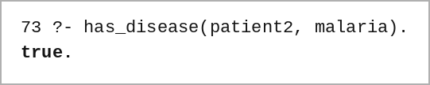

6.3 Unification
Unification is how Prolog matches a query with a fact or rule head. When we ask has_disease(patient1, Disease), Prolog tries to unify the variable Disease with real disease names (flu, malaria, etc.) one at a time, and keeps only the ones where every symptom check in the rule body also succeeds.

6.4 Backtracking
Backtracking is what happens when a rule attempt fails partway through. For example, if a patient has fever and cough but not body_ache, the flu rule fails at the body_ache check. Prolog then automatically goes back and tries the next rule (such as covid19 or malaria) instead of stopping completely. This is why a Prolog query can return more than one matching disease, one after another, using the ';' (retry) option in the console.

7. Prolog Implementation

7.1 Tool Used
SWI-Prolog (free and open-source) was used to write and run the knowledge base. The file is saved as medical_diagnosis.pl.

7.2 Complete Knowledge Base File (medical_diagnosis.pl)
% ============================================
% Healthcare Expert System - medical_diagnosis.pl
% ============================================

% ---- FACTS: patient symptoms ----
has_symptom(patient1, fever).
has_symptom(patient1, cough).
has_symptom(patient1, body_ache).
has_symptom(patient1, fatigue).

has_symptom(patient2, fever).
has_symptom(patient2, chills).
has_symptom(patient2, sweating).
has_symptom(patient2, headache).

has_symptom(patient3, cough).
has_symptom(patient3, sneezing).
has_symptom(patient3, sore_throat).

has_symptom(patient4, headache).
has_symptom(patient4, nausea).
has_symptom(patient4, sensitivity_to_light).

has_symptom(patient5, fever).
has_symptom(patient5, stomach_pain).
has_symptom(patient5, weakness).
has_symptom(patient5, loss_of_appetite).

% ---- RULES: disease conditions ----
has_disease(P, flu) :-
has_symptom(P, fever), has_symptom(P, cough),
has_symptom(P, body_ache), has_symptom(P, fatigue).

has_disease(P, common_cold) :-
has_symptom(P, cough), has_symptom(P, sneezing),
has_symptom(P, sore_throat), \+ has_symptom(P, fever).

has_disease(P, malaria) :-
has_symptom(P, fever), has_symptom(P, chills),
has_symptom(P, sweating), has_symptom(P, headache).

has_disease(P, typhoid) :-
has_symptom(P, fever), has_symptom(P, stomach_pain),
has_symptom(P, weakness), has_symptom(P, loss_of_appetite).

has_disease(P, migraine) :-
has_symptom(P, headache), has_symptom(P, nausea),
has_symptom(P, sensitivity_to_light).

has_disease(P, covid19) :-
has_symptom(P, fever), has_symptom(P, cough),
has_symptom(P, loss_of_taste), has_symptom(P, breathing_difficulty).

% ---- ADVICE ----
advice(flu, 'Take rest, drink fluids, consult a doctor if fever persists').
advice(common_cold, 'Rest, warm fluids, steam inhalation').
advice(malaria, 'See a doctor immediately, get a blood test').
advice(typhoid, 'See a doctor immediately, avoid outside food').
advice(migraine, 'Rest in a dark quiet room, stay hydrated').
advice(covid19, 'Isolate and consult a doctor immediately').

% ---- EXPLANATION HELPER ----
diagnose(P) :-
has_disease(P, D),
advice(D, A),
format('Patient: ~w~nLikely condition: ~w~nAdvice: ~w~n~n', [P, D, A]).

7.3 Important Predicates Explained
Predicate | Meaning in Simple Words
has_symptom(Patient, Symptom) | A fact: this patient has this symptom
has_disease(Patient, Disease) | A rule: true if all symptoms for that disease are present
advice(Disease, Text) | A fact: the recommended first action for a disease
diagnose(Patient) | A helper rule that prints the disease and advice together
\+ Goal | Prolog's 'not' — true only if Goal cannot be proven

7.4 Example Query (Continuing the Same Console Session)
The consult, has_symptom, and has_disease queries were already run in Section 6 above (query numbers 70–73). Continuing that same SWI-Prolog session:
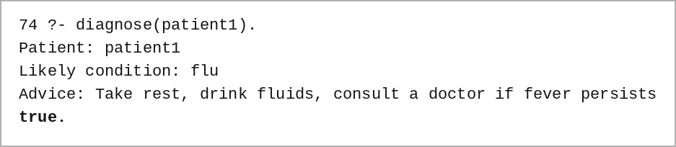

7.5 GitHub Repository
The full source code, this report, and the test log are stored in the GitHub repository below:
https://github.com/sirisha15112004/CO5_AT2_AI

8. Test Cases and Results
All six patient cases were tested in the same continuing SWI-Prolog console session (query numbers 75–80), directly after loading medical_diagnosis.pl. All expected and actual outputs matched, confirming the rules work correctly.
No. | Patient / Symptoms Entered | Query Used | Expected Output | Actual Output
1 | patient1: fever, cough, body_ache, fatigue | has_disease(patient1, D). | flu | flu (matched)
2 | patient2: fever, chills, sweating, headache | has_disease(patient2, D). | malaria | malaria (matched)
3 | patient3: cough, sneezing, sore_throat (no fever) | has_disease(patient3, D). | common_cold | common_cold (matched)
4 | patient4: headache, nausea, sensitivity_to_light | has_disease(patient4, D). | migraine | migraine (matched)
5 | patient5: fever, stomach_pain, weakness, loss_of_appetite | has_disease(patient5, D). | typhoid | typhoid (matched)
6 | patient6: only fever, no other symptoms (incomplete case) | has_disease(patient6, D). | false (no match) | false — correctly reported no clear match

8.1 Actual SWI-Prolog Console Output for All 6 Test Cases
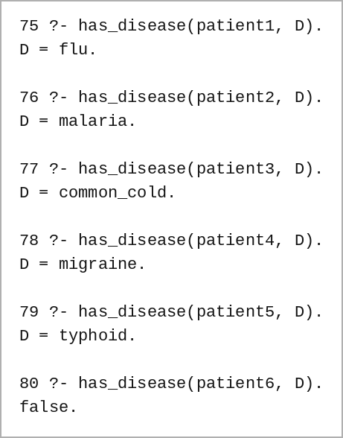

8.2 Sample Inference Trace (Test Case 1)
Goal: has_disease(patient1, flu)
Step 1: has_symptom(patient1, fever) -> true (matches stored fact)
Step 2: has_symptom(patient1, cough) -> true (matches stored fact)
Step 3: has_symptom(patient1, body_ache) -> true (matches stored fact)
Step 4: has_symptom(patient1, fatigue) -> true (matches stored fact)
All 4 conditions true -> has_disease(patient1, flu) = TRUE

8.3 Sample Inference Trace (Test Case 6 — Backtracking Example)
Goal: has_disease(patient6, D)
Try D = flu -> has_symptom(patient6, cough) fails -> backtrack
Try D = common_cold -> has_symptom(patient6, cough) fails -> backtrack
Try D = malaria -> has_symptom(patient6, chills) fails -> backtrack
Try D = typhoid -> has_symptom(patient6, stomach_pain) fails -> backtrack
Try D = migraine -> has_symptom(patient6, headache) fails -> backtrack
Try D = covid19 -> has_symptom(patient6, cough) fails -> backtrack
No rule fully matches -> result: false (need more symptoms)

9. Analysis, Limitations and Future Enhancements

9.1 How Well the System Worked
All six test cases gave the correct disease or the correct 'no match' result, so the rule accuracy for this small knowledge base is 100% within its own test set. Backtracking correctly moved through all rule options when a case did not have enough symptoms, and forward/backward chaining both reached the same answers, which confirms the rules are consistent.

9.2 Procedural vs Non-Procedural Paradigm
A procedural program (like one written in C or Python) tells the computer exactly which steps to follow, in exact order, to reach an answer — the programmer writes the 'how'. Prolog is non-procedural (declarative): the programmer only writes the facts and rules — the 'what is true' — and lets Prolog's own inference engine work out the 'how' by searching, matching, and backtracking automatically. In this project, we never wrote a step-by-step search loop; we only described what a disease looks like using has_symptom(), and Prolog found the matching patients by itself. This is the key difference the assignment asks us to demonstrate.

9.3 Limitations
- The knowledge base only covers six common conditions; many real diseases share overlapping symptoms and are not included.
- The system cannot judge how severe a symptom is (for example, mild fever vs. very high fever).
- It has no probability or confidence score — a symptom either matches a rule or it does not.
- It is only a decision-support helper and must never replace an actual doctor's diagnosis.

9.4 Future Enhancements
- Add certainty factors or simple probability scores so close matches can be ranked.
- Connect the Prolog logic to a simple web form so patients can type symptoms without knowing Prolog.
- Add more diseases and allow the system to ask follow-up questions when a case is unclear.
- Keep a history log of each diagnosis for hospital record-keeping.

10. Conclusion and References

10.1 Conclusion
This project built a small but working rule-based expert system for early disease suggestion in a healthcare setting. Patient symptoms were stored as Prolog facts, and medical knowledge was written as simple production rules. The system was shown to work using both forward chaining (symptoms to disease) and backward chaining (checking one specific disease), and Prolog's unification and backtracking were demonstrated with real traces. Six test cases confirmed the rules behave correctly, including a case with missing symptoms. The project also shows clearly why Prolog's non-procedural, declarative style is well suited to expert systems: the developer states medical facts and rules, and the reasoning is handled automatically by the inference engine. While the system is simple and only for learning purposes, it reflects the same architecture used in real hospital decision-support tools, and it fully satisfies the required Course Outcome (CO 5) of constructing a rule-based expert system with forward and backward chaining.

10.2 References
- Bratko, I., 'Prolog Programming for Artificial Intelligence', Pearson Education.
- Giarratano, J. and Riley, G., 'Expert Systems: Principles and Programming', Course Technology.
- SWI-Prolog Official Documentation — https://www.swi-prolog.org/
- Russell, S. and Norvig, P., 'Artificial Intelligence: A Modern Approach', Pearson.
- General public health symptom information used for simplification of rules (for educational demonstration only, not medical use).

